Rebríček členov ŠO TJ Slovan Gelnica
podľa národného ratingu k 1.11.2007

Poradie | Foto | Priezvisko, meno a rok nar. hráča | ELO  FIDE | OK  (ELO-N)
1 | 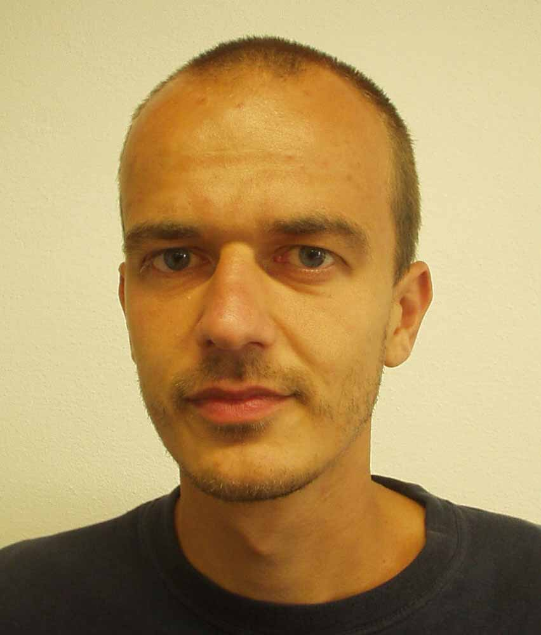 | Regec, Viliam (1977) | 2210 | 2224
2 | 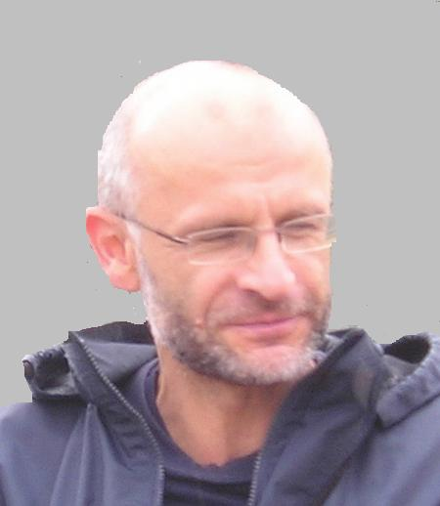 | Bláha Vladimír (1957) |  | 2138
3 | 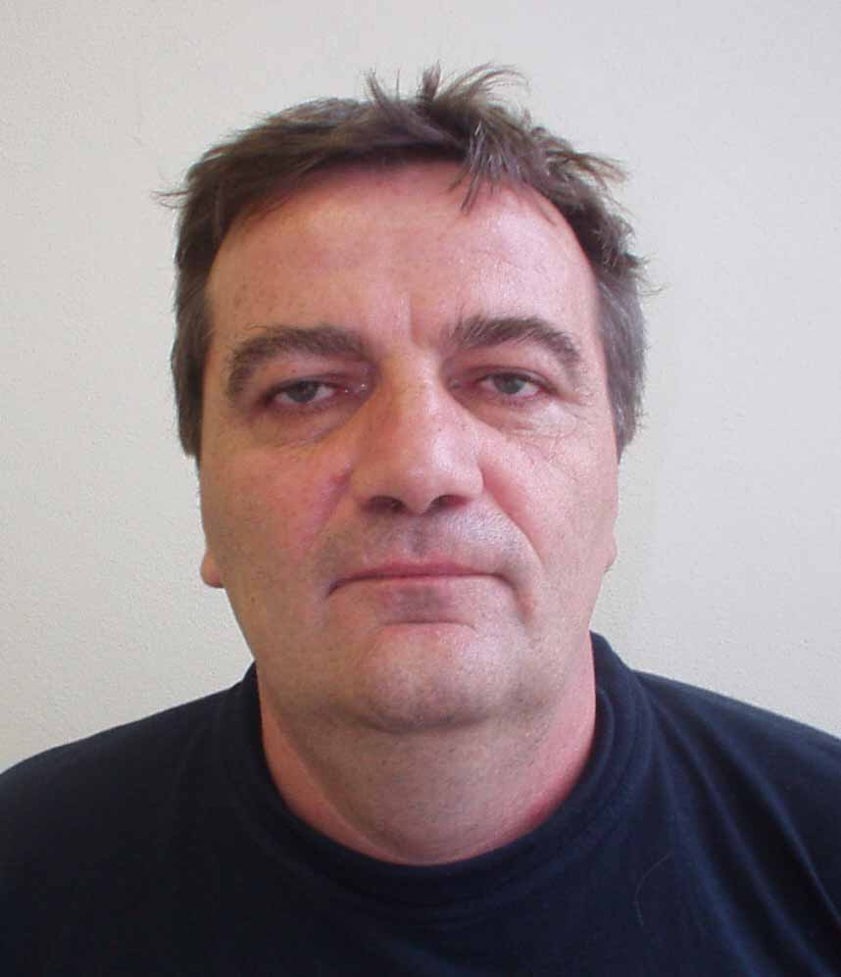 | Majláth, Zdenko (1960) | 2054 | 2030
4 | 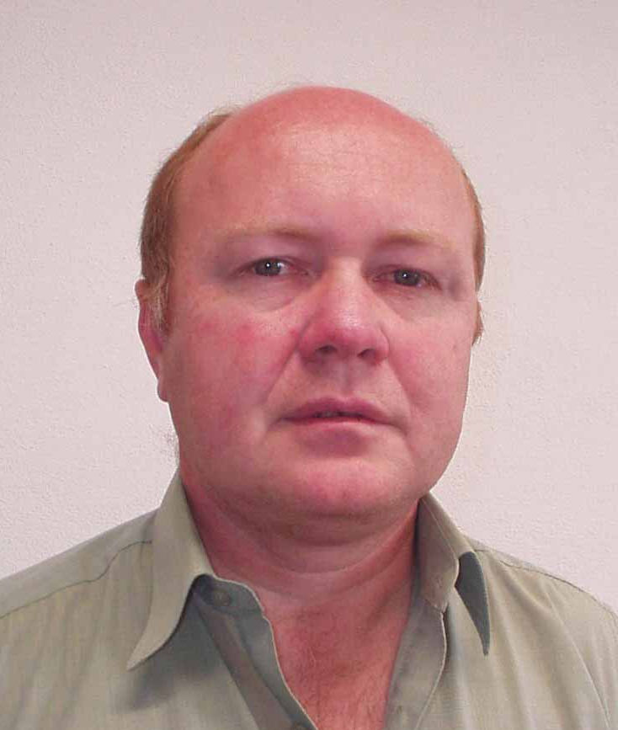 | Turzák, Milan (1959) | 1996 | 2020
5 | 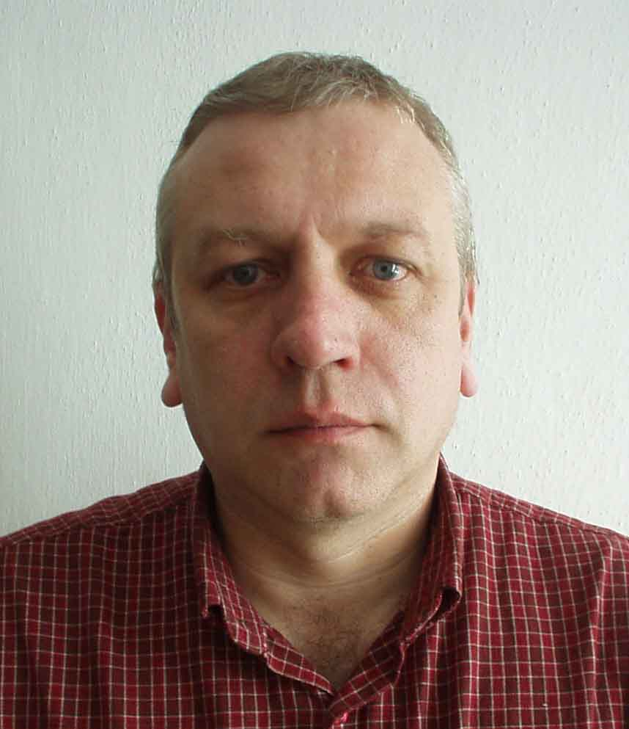 | Kaľavský, František (1959) | 1983 | 1932
6 | 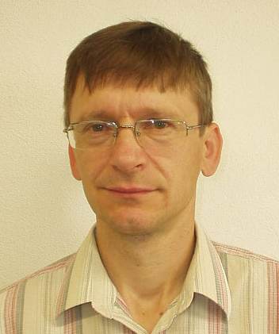 | Fedor, Jaroslav (1961) |  | 1921
7 | 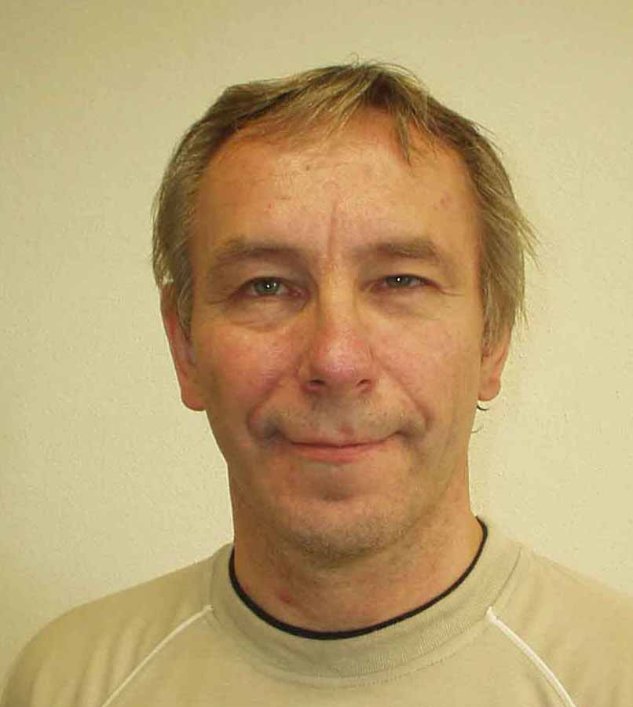 | Brutovský, František (1962) |  | 1899
8 | 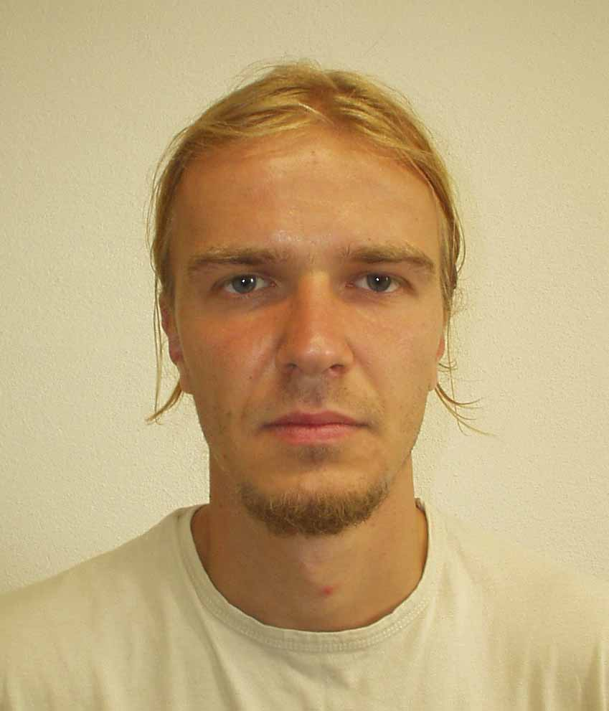 | Regec, Richard (1981) |  | 1835
9 | 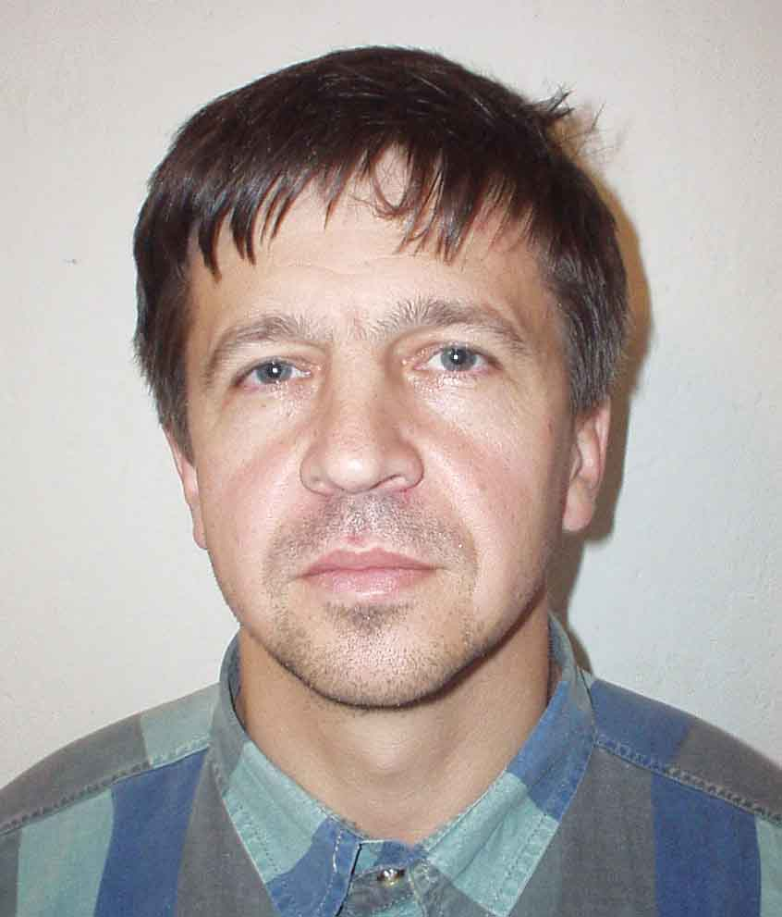 | Sedmák, Viktor (1964) |  | 1826
10 | 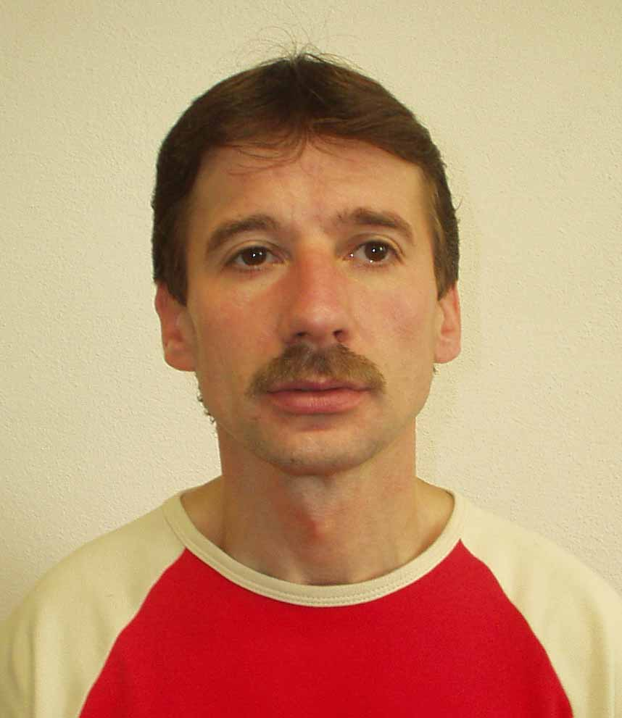 | Visocký, Peter (1969) |  | 1785
11 | 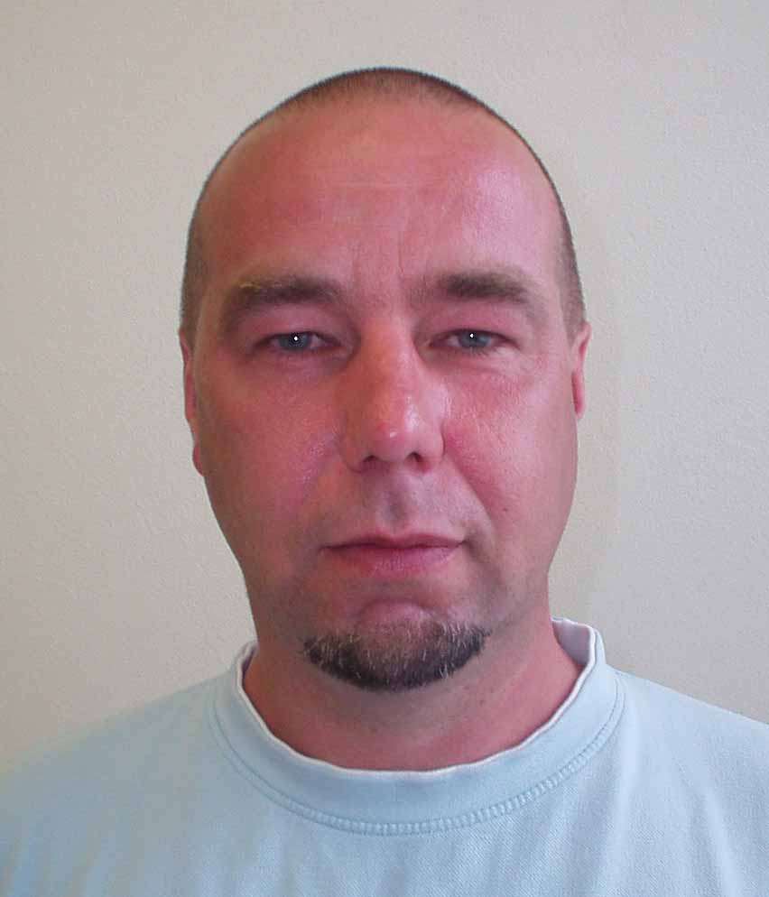 | Vilčko, Juraj (1963) |  | 1759
12 | 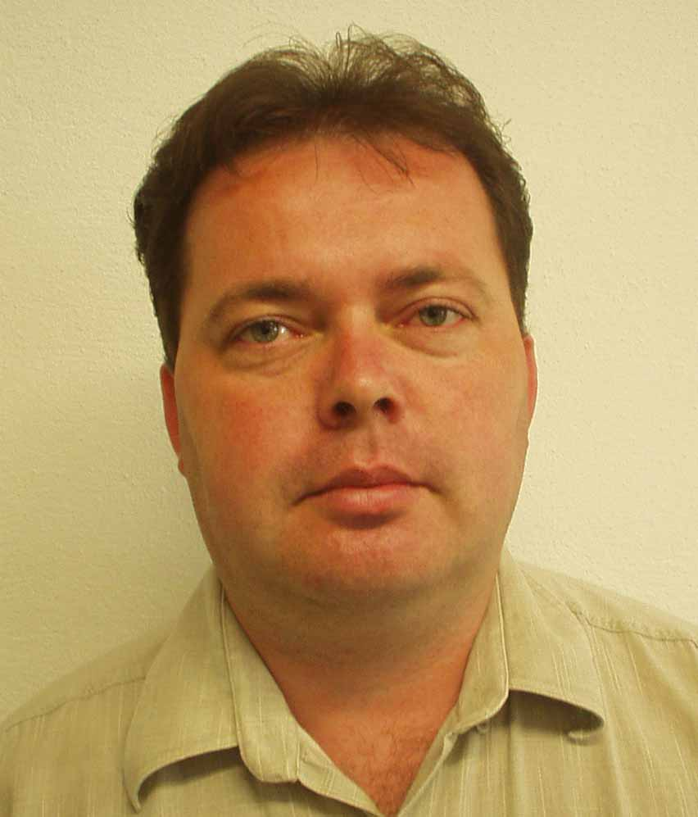 | Kollár, Ľubomír (1970) |  | 1712
13 | 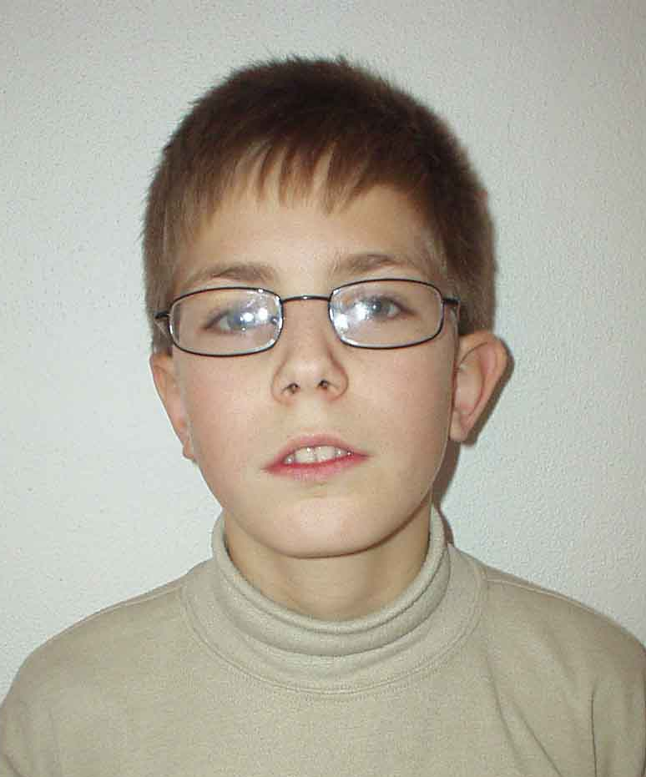 | Turzák, Milan (1992) |  | 1711
14 | 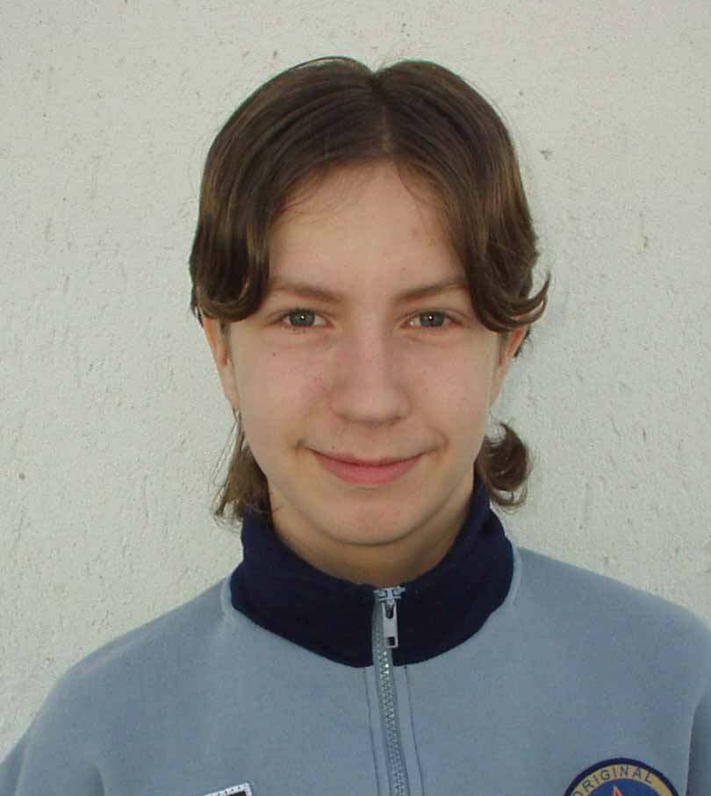 | Petko, Peter (1991) |  | 1708
15 | 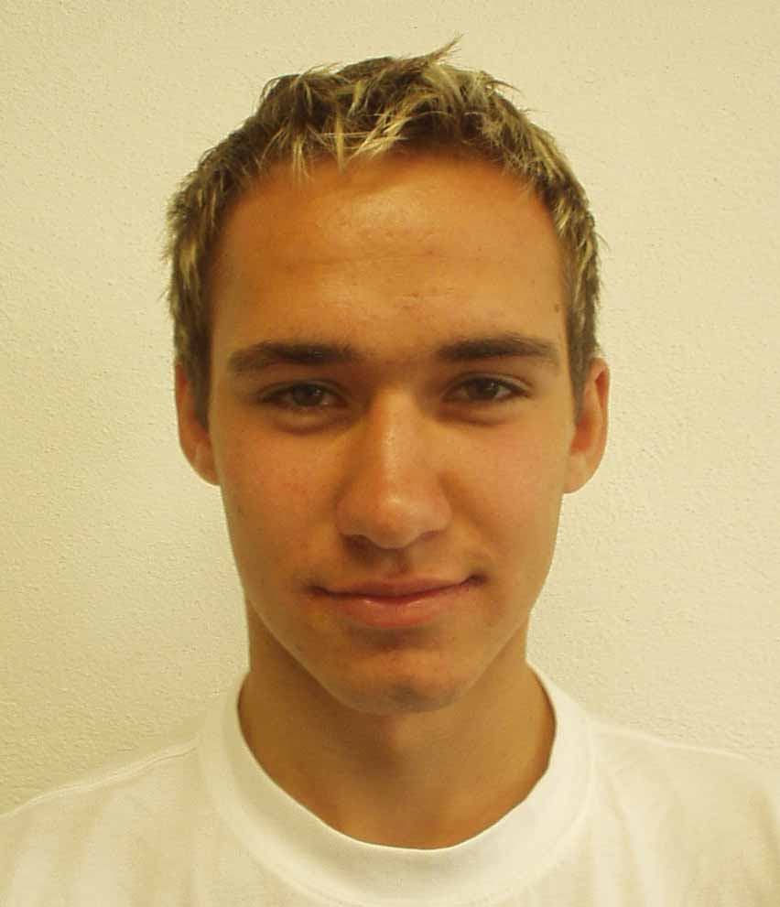 | Tomaško, Dušan (1987) |  | 1689
16 | 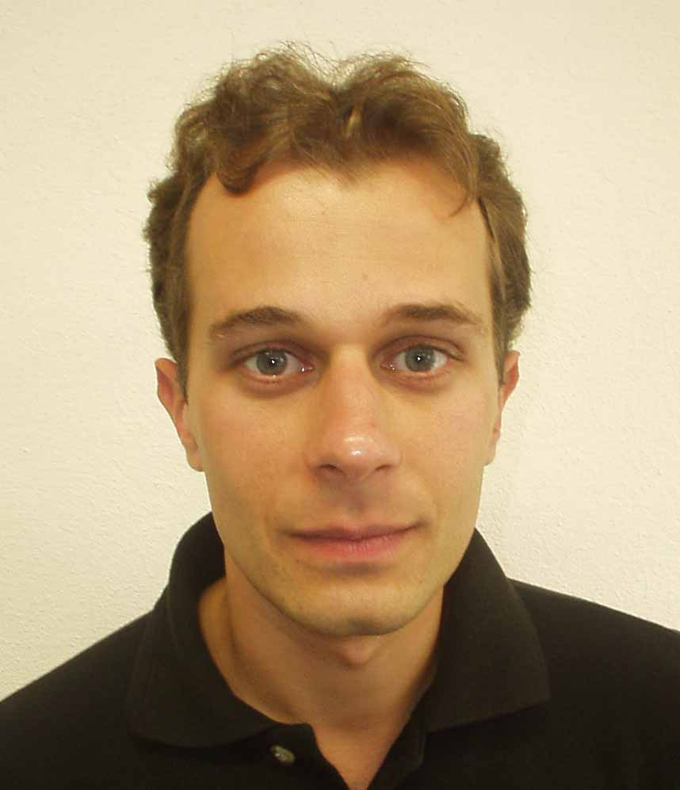 | Kaľavský, Ľubomír (1976) |  | 1641
17 | 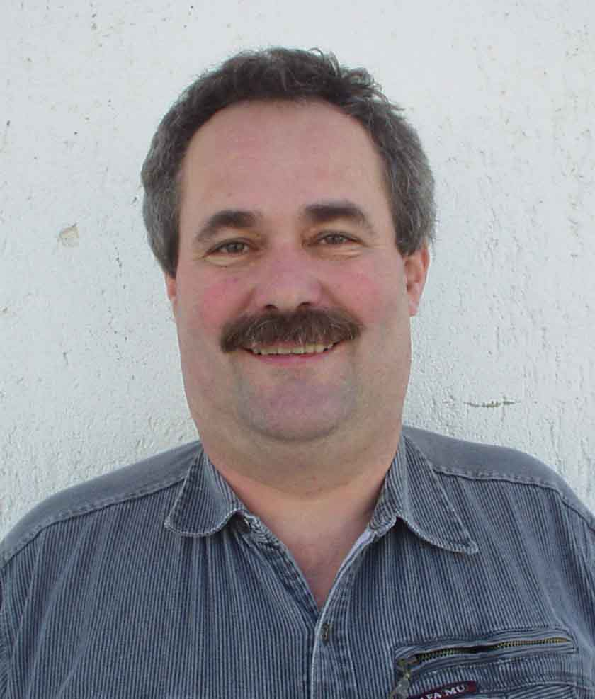 | Kiseľ, Peter (1960) |  | 1621
18 | 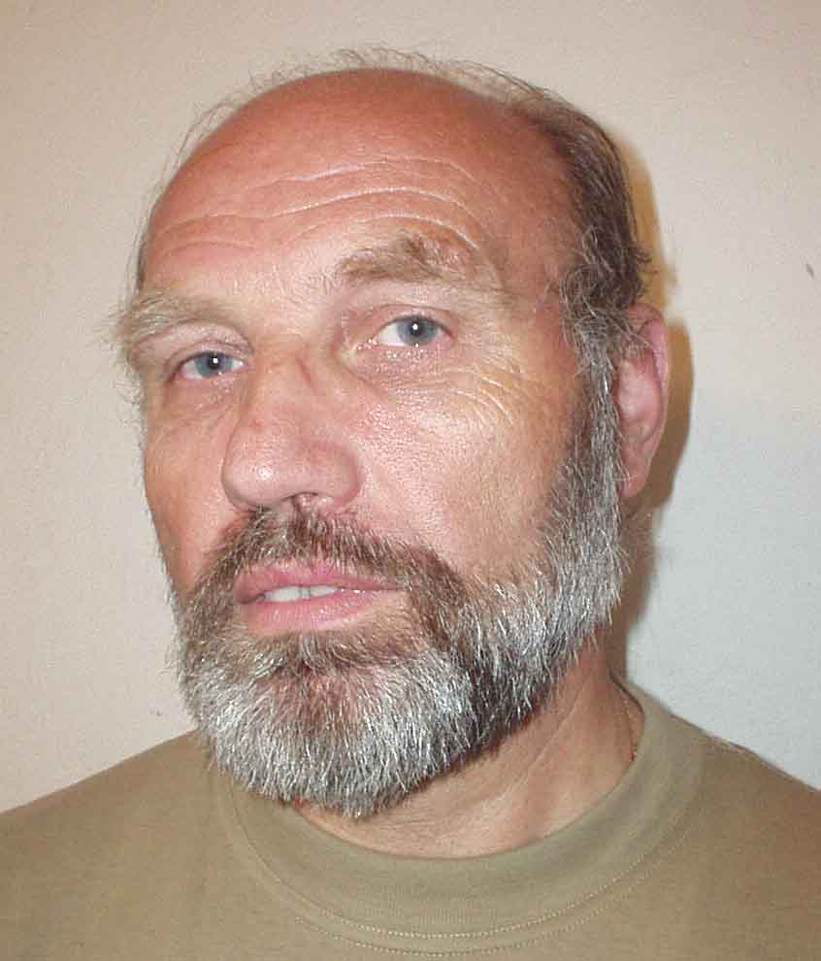 | Slivka, Štefan (1951) |  | 1606
19 | 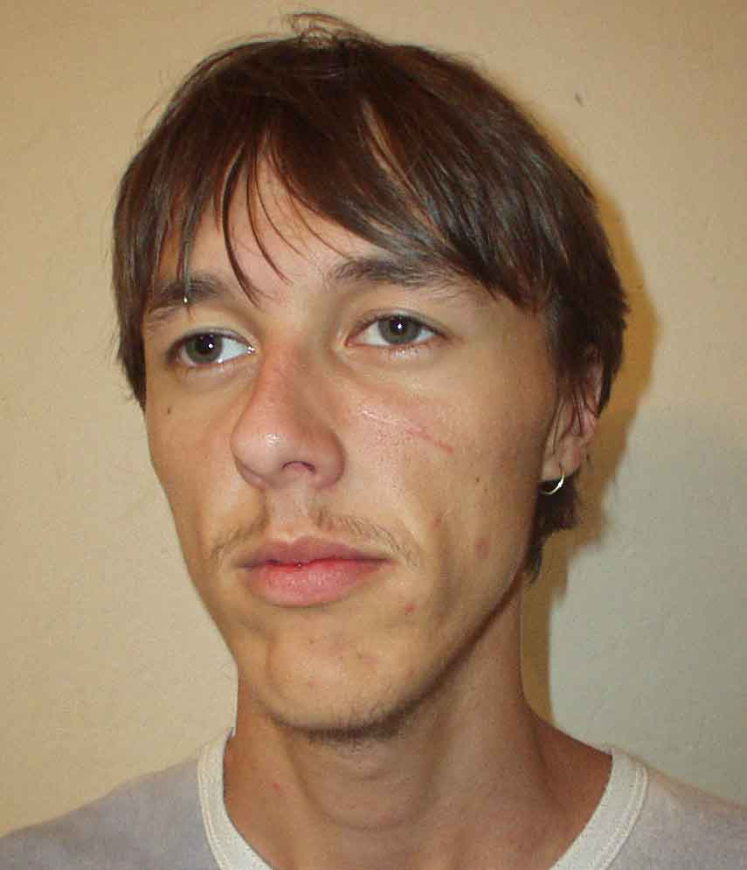 | Keruľ, Jozef (1985) |  | 1603
20 | 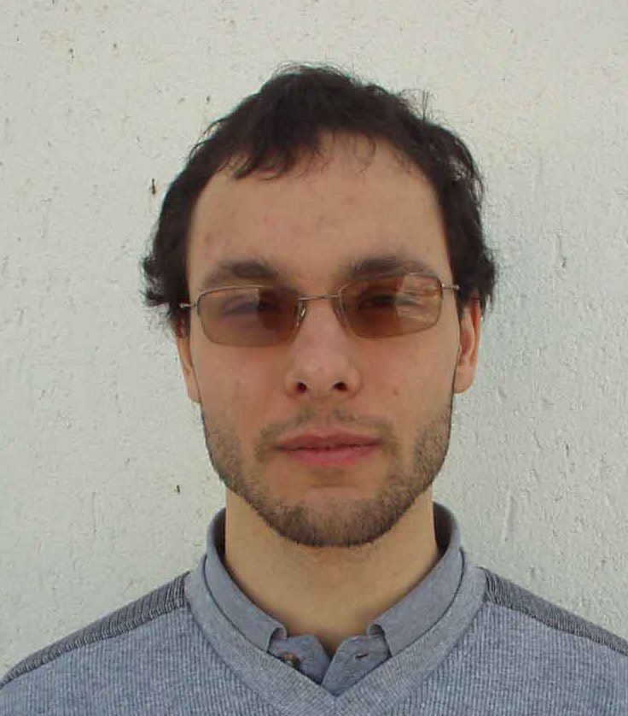 | Kluknavský, František (1986) |  | 1576
21 | 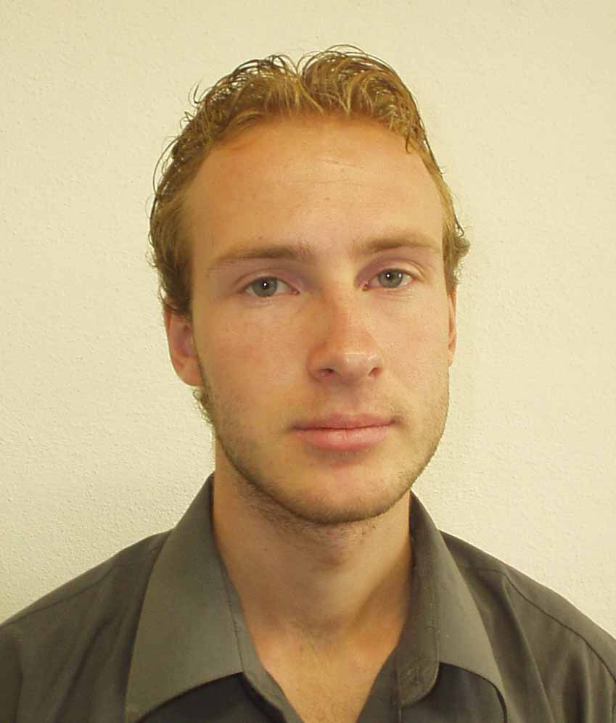 | Jenčík, Jozef (1984) |  | 1501
22 | 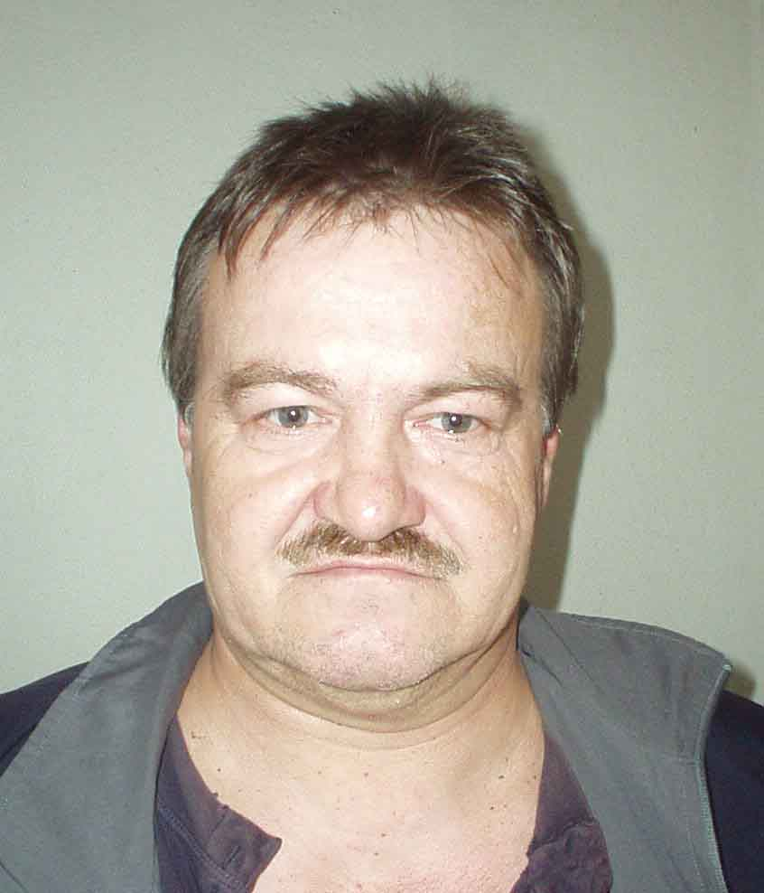 | Jalč, Matej (1955) |  | 1467
23 | 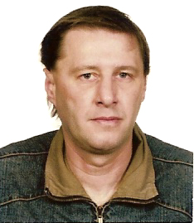 | Konečný, Peter (1967) |  | 1454
24 | 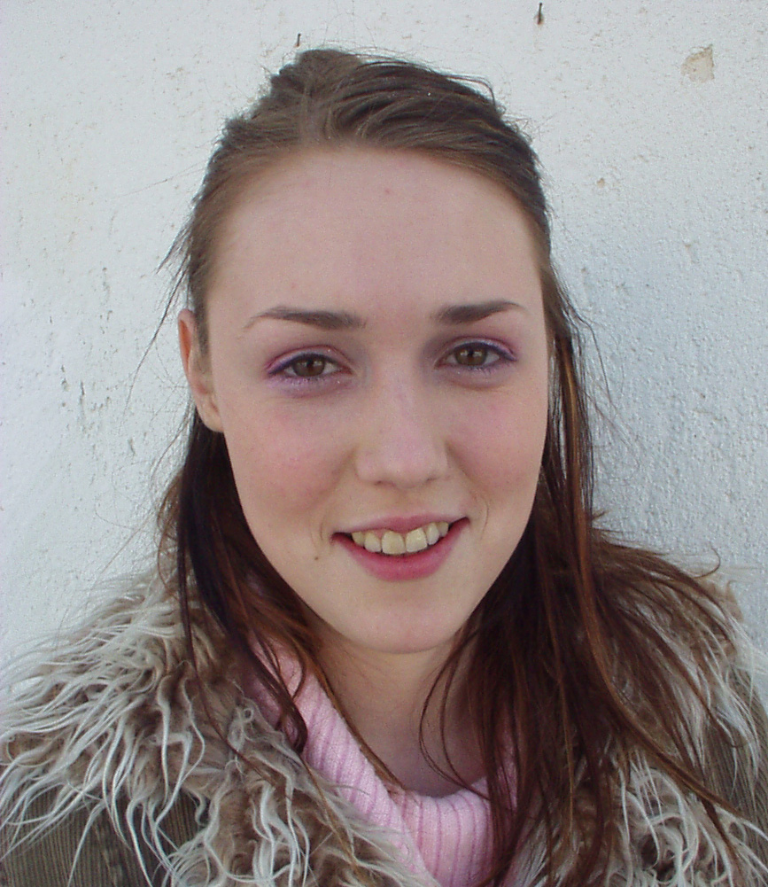 | Kiseľová, Lucia (1986) |  | 1434
25 | 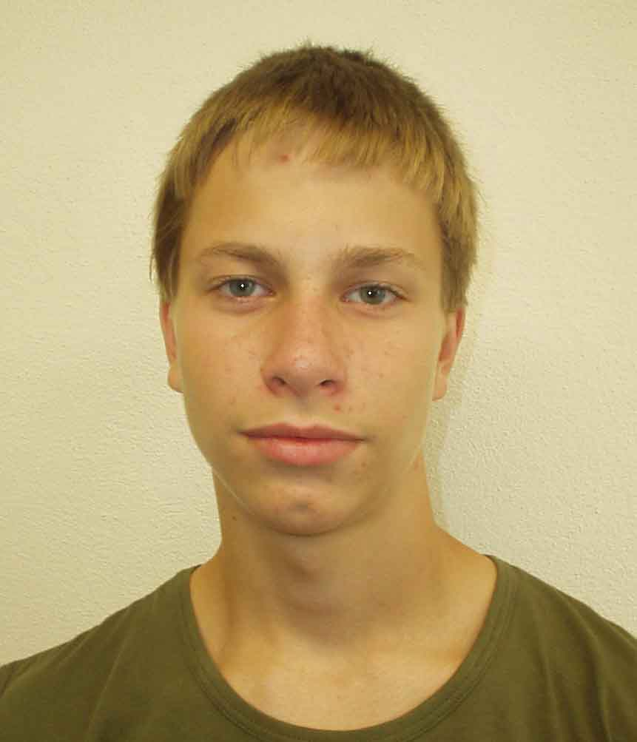 | Dromblikovič, Štefan (1991) |  | 1413
26 | 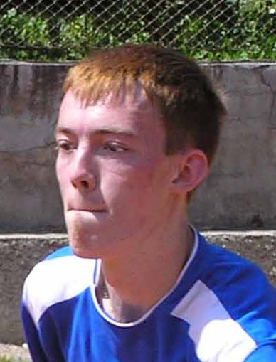 | Kiseľ, Peter (1985) |  | 1408
27-32 | 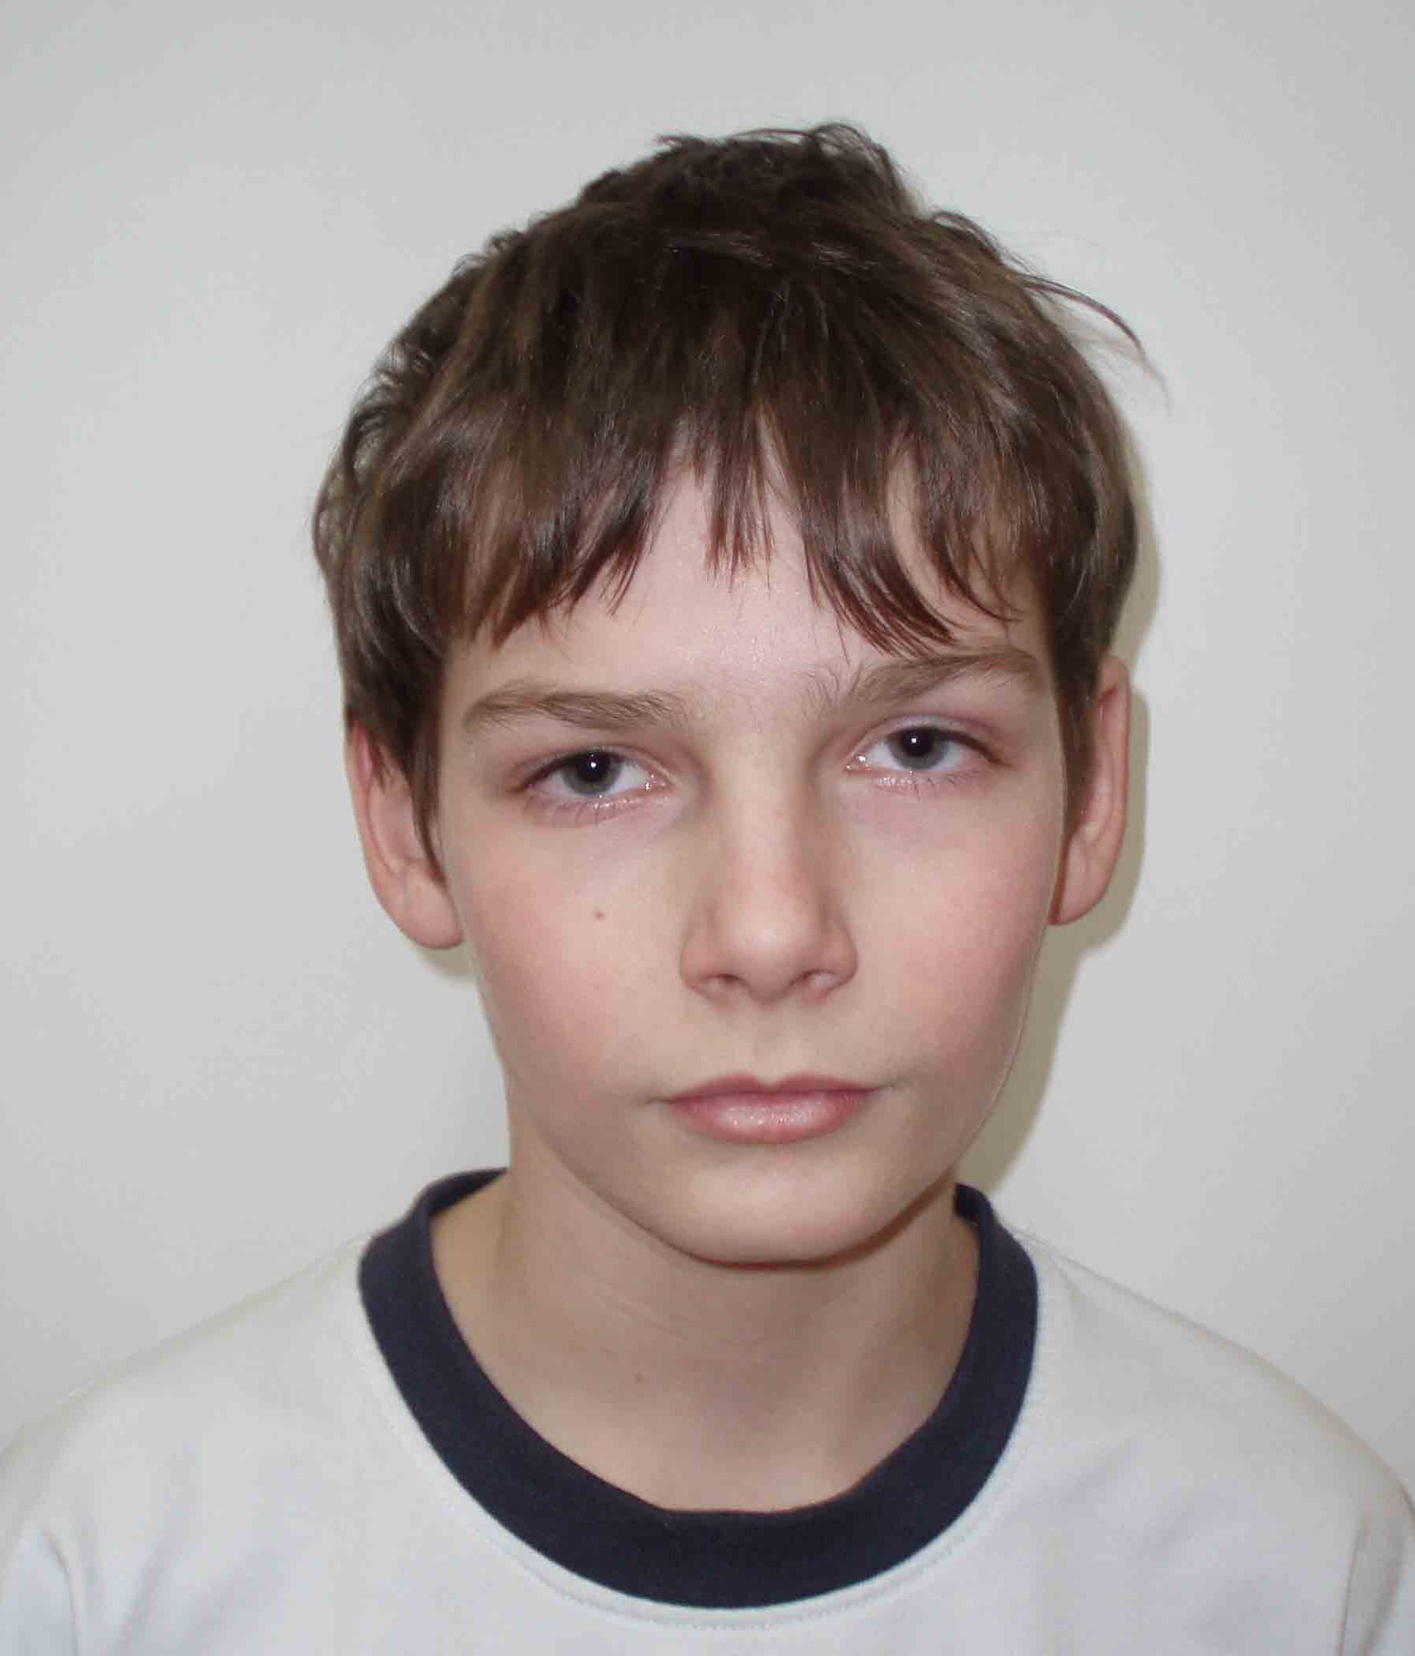 | Lacko, René (1993) |  | 1350
27-32 | 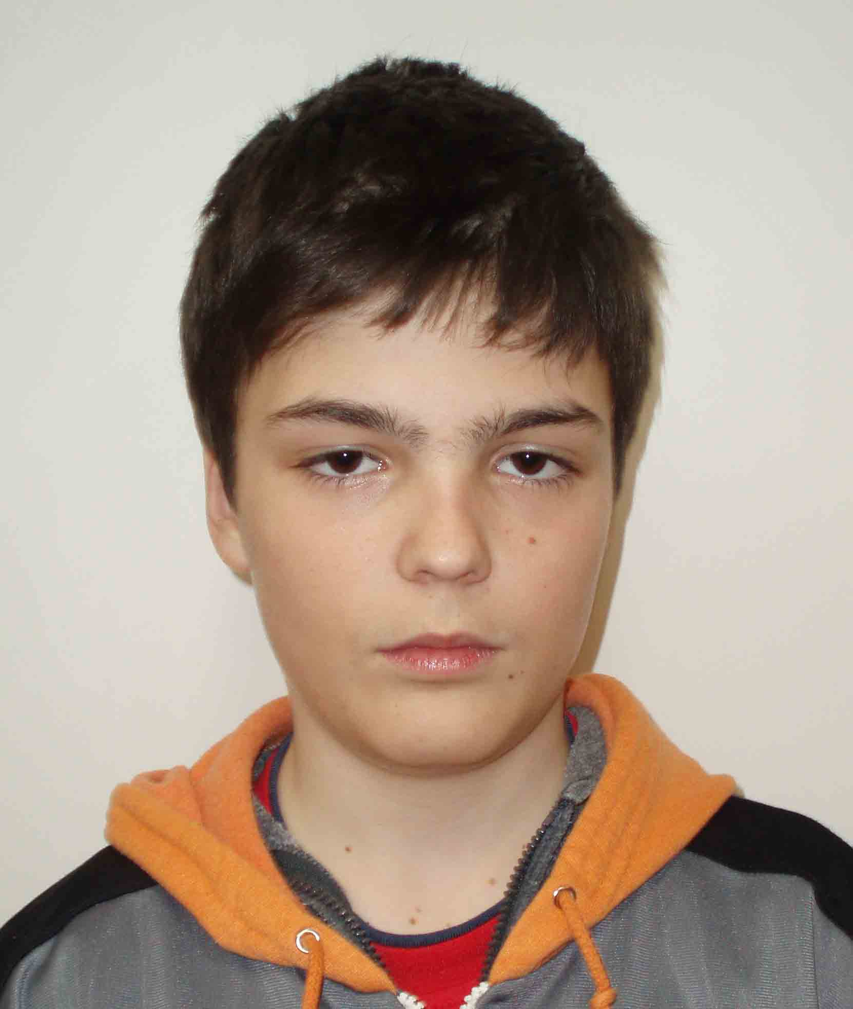 | Kollár, Adrián (1994) |  | 1350
27-32 | 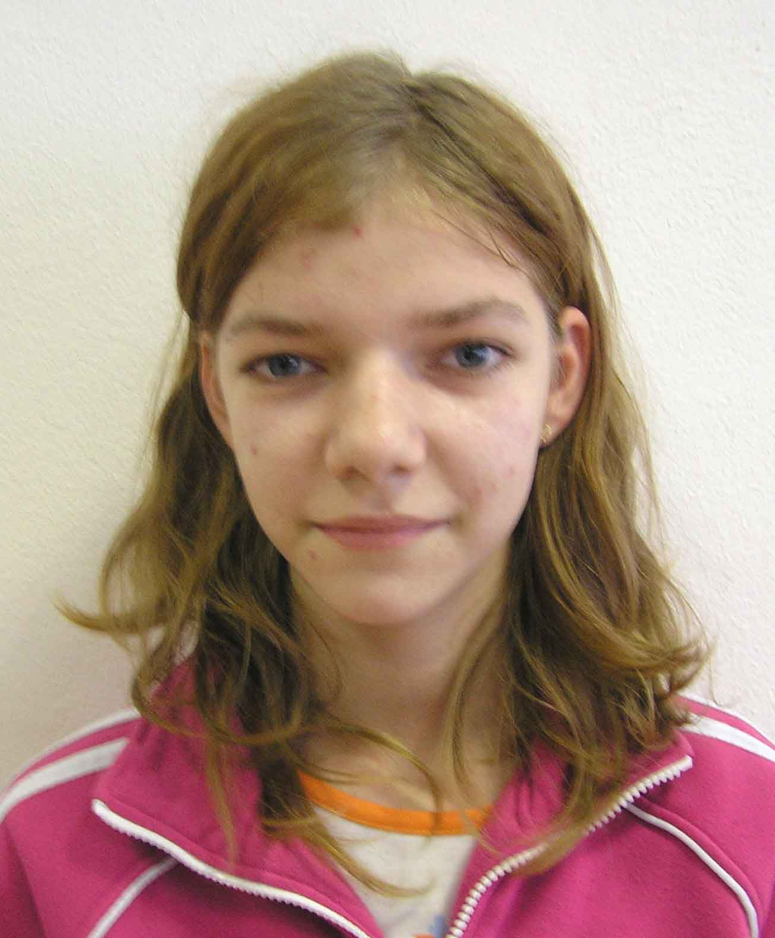 | Bonková, Michaela (1991) |  | 1350
27-32 | 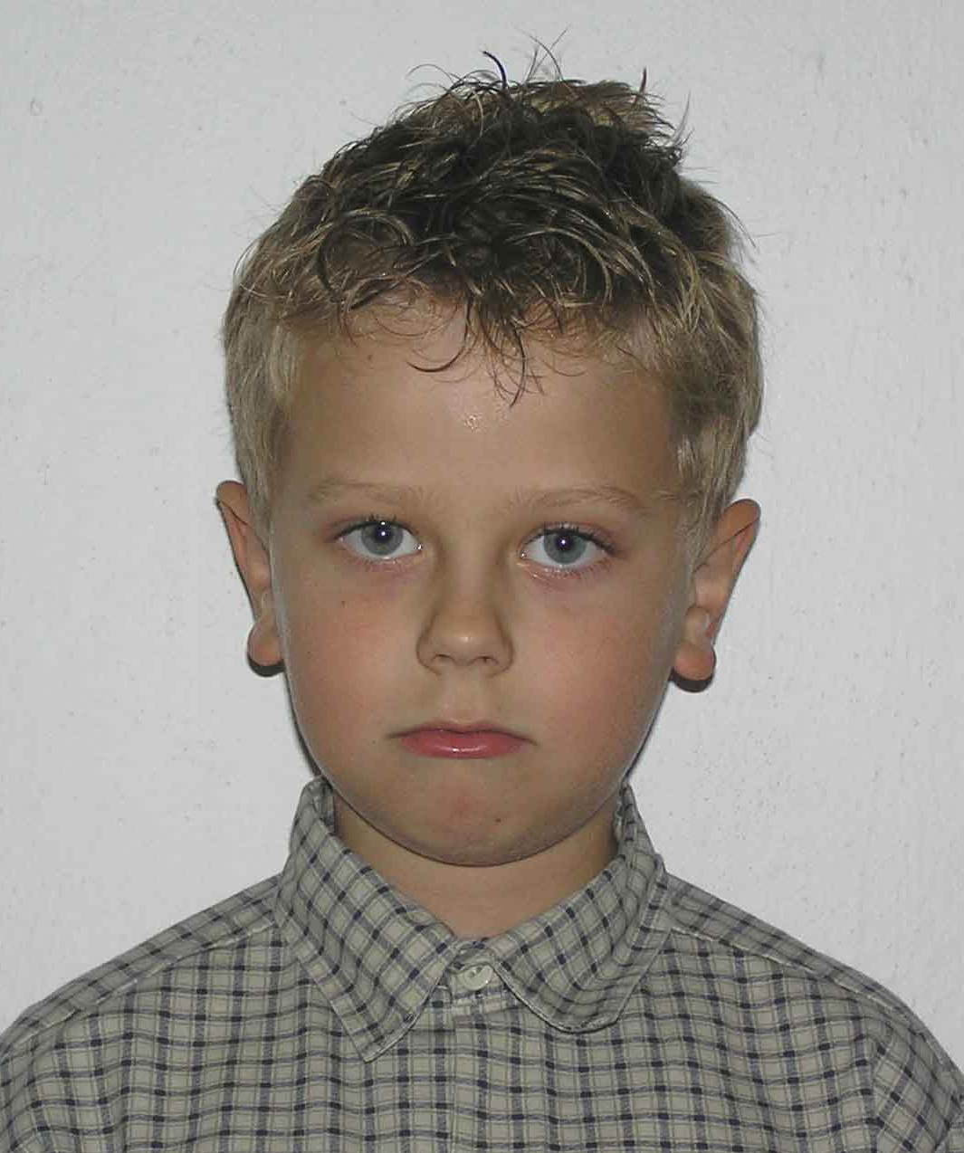 | Pohly, Jakub (1999) |  | 1350
27-32 |  | Fidler, Ľubomír (1992) |  | 1350
27-32 | 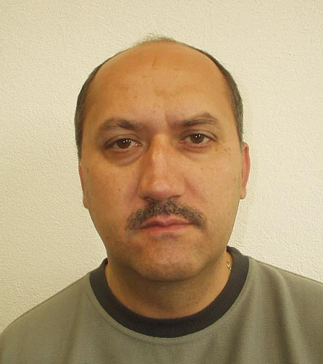 | Tomaško, Dušan (1963) |  | 1350

